Eve O’Hagan

2251923O

WEB SCIENCE

ASSIGNMENT

GITHUB:

https://github.com/EveOHagan/2251923oWebScienceAssignment

INTRODUCTION:

For my assignment, in order to gather the Twitter Information required , I registered as a Twitter Developer. From this, an App was created in order to generate Consumer API Keys and Access Token Keys, which provides authentication and access to the Twitter Developer account to use the App created.

MongoDB is a database, that I used to store the data of tweets collected once the Streaming API had been complete.

To stream the tweets, I developed a program whilst using Tweepy and Twitter Streaming API. Tweepy is a well known Python library for accessing the Twitter API. I was influenced by Sam Delgado Code in order to create the program for this assignment. (GitHub <https://github.com/SamDelgado/twitter-to-mongo/blob/master/twitter-to-mongo.py>)

I chose to stream tweets that contained “bexit”, “boris” and “#brexit”. However, the tweets which have been streamed into my database are not entirely representable of this topic, it is representable of the topic at the time the tweets where taken due to the live events that were occurring.

My Data Sample was collected on the 3rd March 2020. I collected around 9012 tweets in total.

SECTION 2: DATA CRAWLER

Tweepy was used in order to complete the Data Crawler Section of this assignment.

The API used were the Twitter Streaming API and the Rest API to collect and filter the tweets. In order to crawl the data, firstly a MongoDB connection was made. This was using the connection of the Local Host. From this, I specified the key words which I wanted to track “brexit”, “boris” and “#brexit” and ensured that the only language I wanted to capture was English.

To stream the tweets I used the ‘StreamListener’ Twitter Streaming API from Tweepy. This allowed me to create a persistent connection to the Twitter and read each connection incrementally. A benefit of the Stream Listener API is it allows to process tweets quickly as well as deal with handling errors correctly and efficiently.

To filter the tweets I used the ‘Rest API’ supplied by Tweepy. By doing do, this allowed to track the keywords of ‘brexit’ ‘boris’ and ‘#brexit’. By using the REST API, it allowed the handling of data formats which were different for each element of the tweets streamed.

Furthermore, I introduced a cursor to initialise the Twitter REST API. This allowed me to write the list of followers of each user to a separate file and to investigate the followers each user has.

The code created ensured that the tweets gathered from the stream would only store the important fields to my MongoDB. I used the StreamListener method of “on_data” which automatically allows extraction of the kind of Twitter data. Firstly, the tweet was loaded into a variable and parsed using “json.load(data)” which in turn adds each tweet to a Python Dictionary. By using the “on_data” method the Tweet ID, username of the tweet author, number of followers the author has, the content of the tweet, hashtags used within the tweet, the timestamp of the tweet when it was created and the language. This information was placed and stored within the MongoDB.

In the case that an error occured, an “on_error” method is used which creates an error status message and prints on the command line.

SECTION 3:

In order to group the tweets, I used the method of K-Means clustering. I decided to cluster each in groups of 8 to give a strong representation of the data collected.

To begin with, a CSV file was read in which contained the data streamed. I extracted the username, hashtag and text from tweets. Each username, hashtag and tweets were vectorised using “TfidVectorizer” in order to allow the data to be fitted and transformed using “fit_transform().”

I created a program that used a for loop to iterate through the usernames, and print the 10 top usernames per cluster. I repeated this same process to print the top 10 text per cluster and the top 10 hashtags per cluster.

I used K-Means method of clustering, and this was due to the fact that K-Means is simple to implement and I have had no experience clustering before. It also can produce tighter clustering than others such as hierarchal clustering. To aid my program, I used the Scikit to further my understanding <https://scikit-learn.org/stable/modules/generated/sklearn.cluster.KMeans.html> I also was influenced by https://stackoverflow.com/questions/27889873/clustering-text-documents-using-scikit-learn-kmeans-in-python?fbclid=IwAR0MKdKpJisRXqB3i4JMLtb_folruKVR-6gEOX9abVtZfiLstqJVbgz2H-A

The groups are formed in K-Means clustering by first setting the number of clusters. From this, the K-Means generates through the tweets to find a ‘natural pattern’. It does not set specified groups initially, then attempt to slot the relevant information into each group. Due to this, results may end up similar because of the natural patterns found whilst other information clusters may not seem as relevant to each other.

TOP 10 USERNAMES PER CLUSTER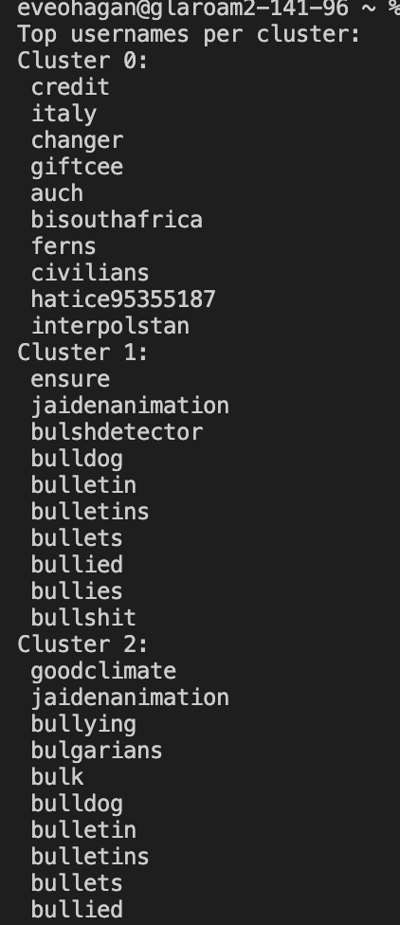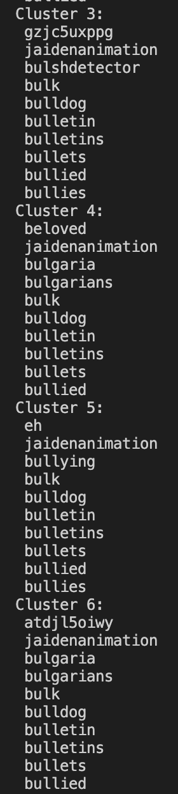

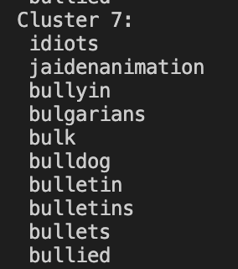

TOP 10 HASHTAGS PER CLUSTER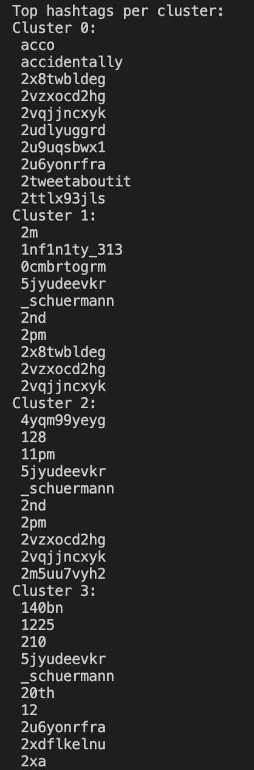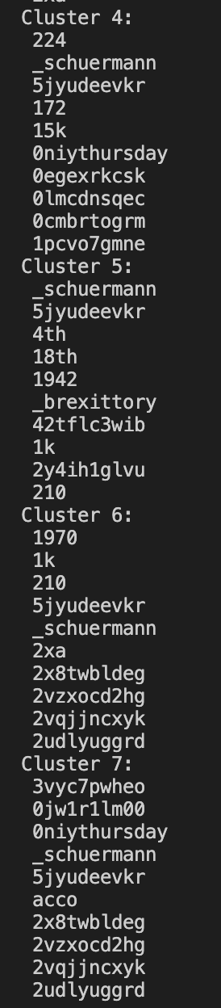

TOP 10 TEXT PER CLUSTER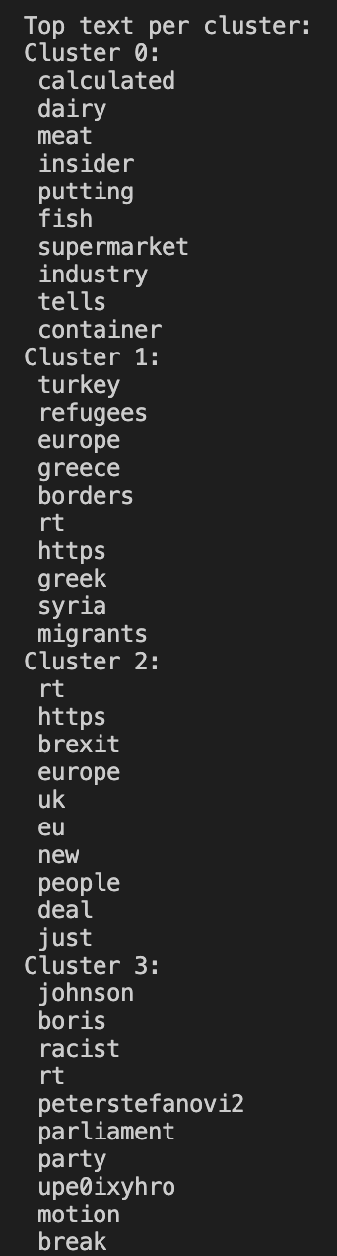

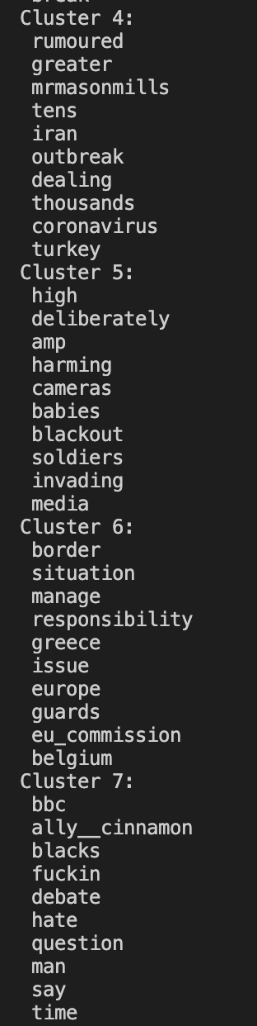

**SECTION 4:**

**Interaction Graphs for the Original Data collected**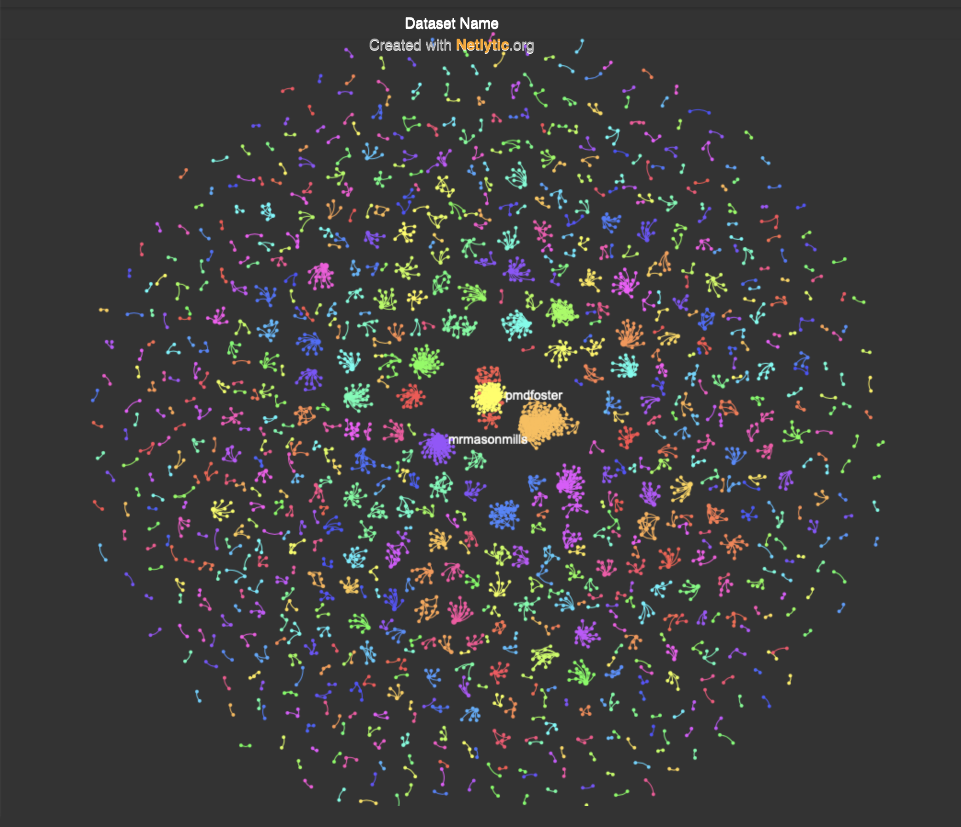

*Figure 1*

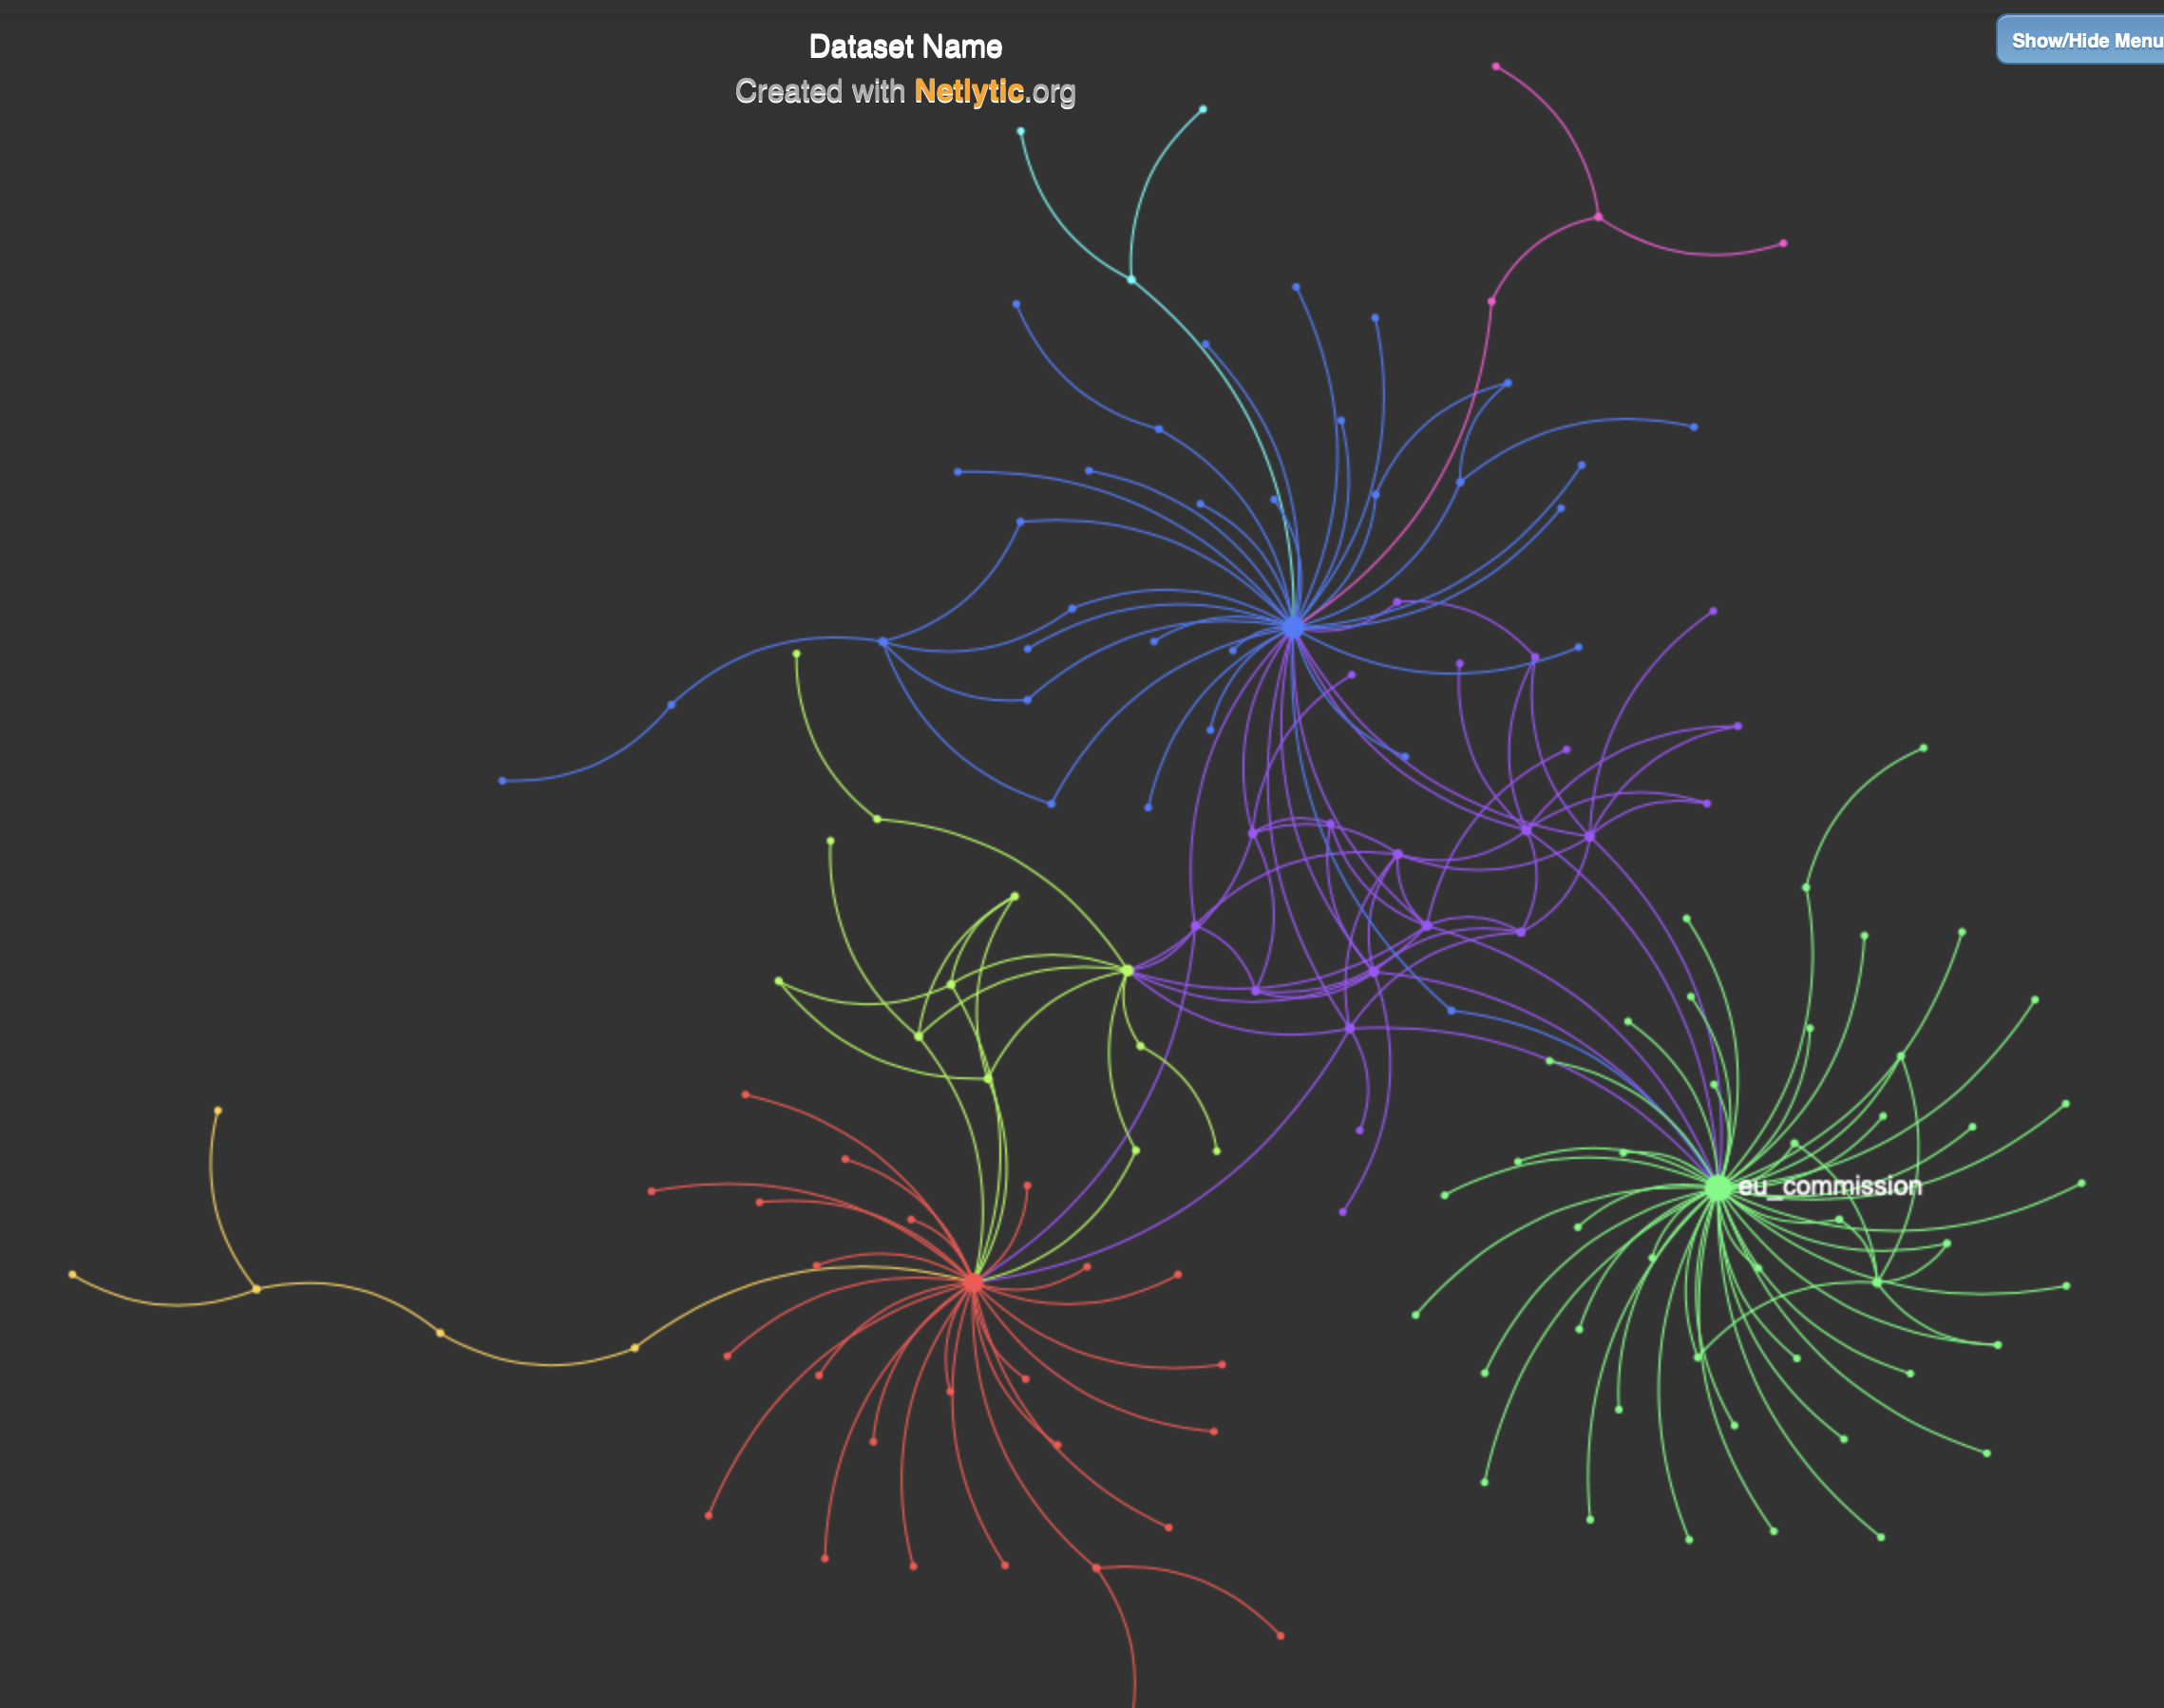

*Figure 2*

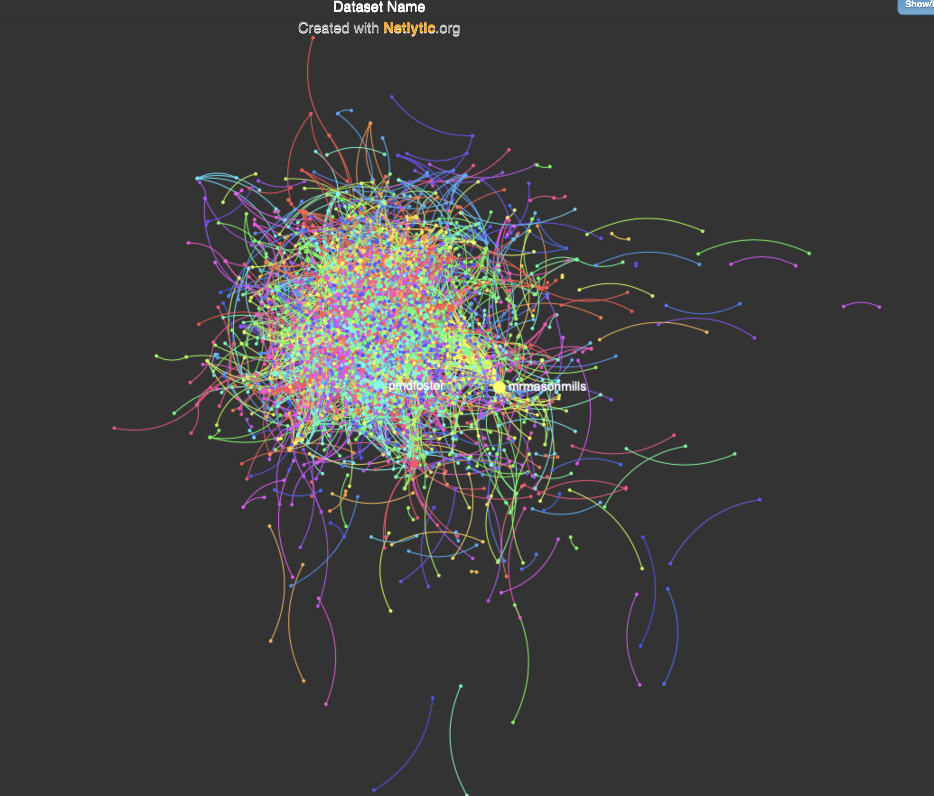

*Figure 3*

*Figure 5*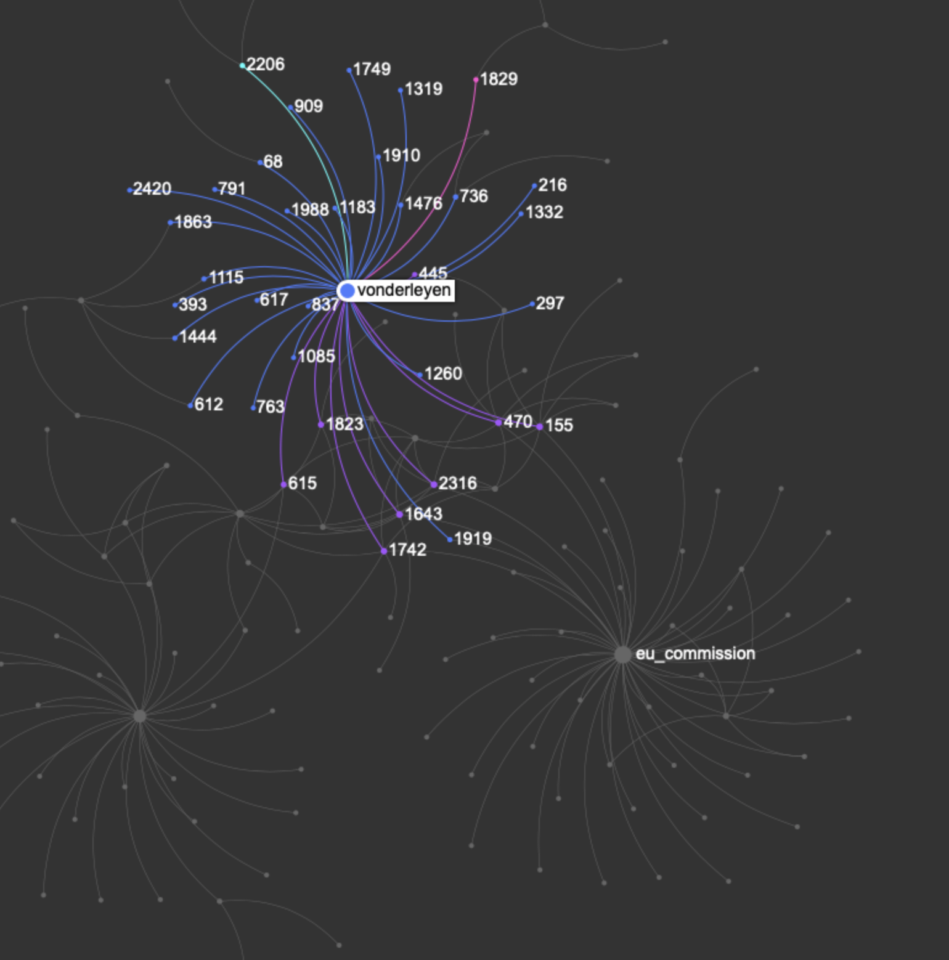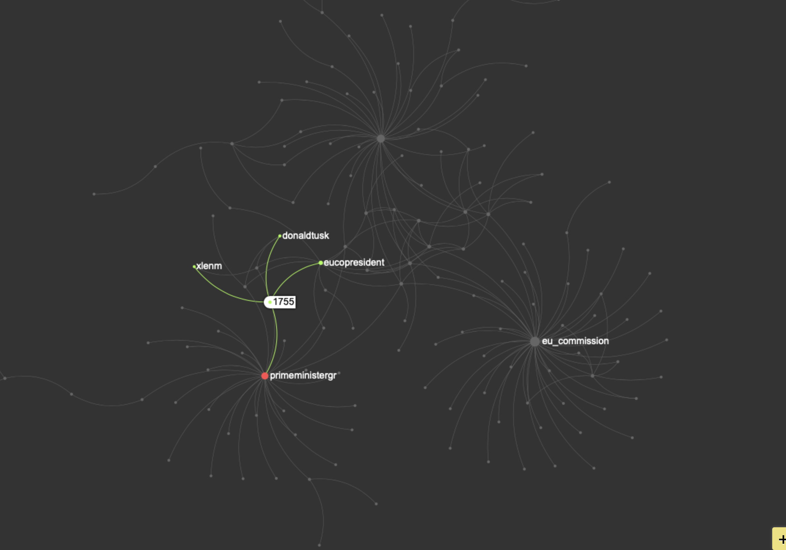

*Figure 4*

In order to create the user interaction graphs, I first converted the data from the MongoDB database into a CSV file. This was due to the fact, it made filtering and manipulating the data needed much simpler. This also allowed me to use Netlytic, which is a software to generate User Interaction Graphs.

I began by creating a user interaction graph for the original data collected. This would allow me to compare the manipulated graphs to the original.

From the graphs displayed, it is poignant that there is a lot of user interaction to regarding this important topic. As displayed in the graph is Figure 1, it can be seen there was a lot of discussion of “Brexit” during the time which I streamed the tweets.

Figure 4 and 5 is a closer look at the interactions that occured within this topic. “Vonderleyen” had the most user interactions thus creating one of the largest nodes of the graph containing the edges which represent the interactions.

**Only Mentions, No Retweets**

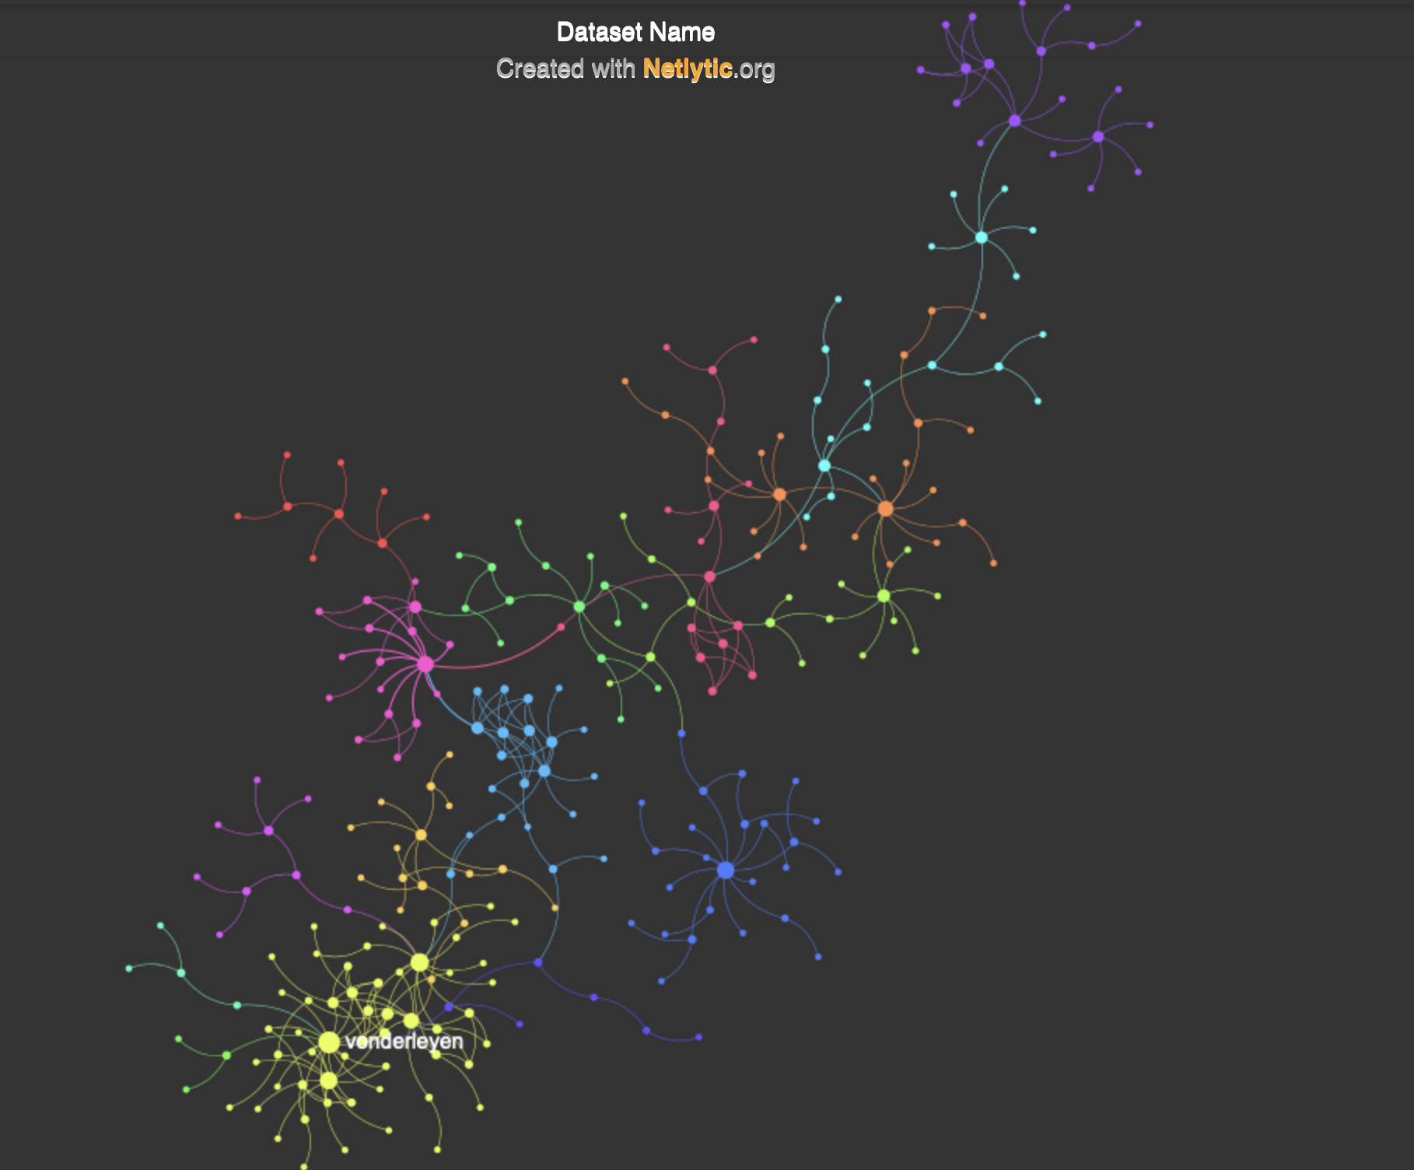

*Figure 6*

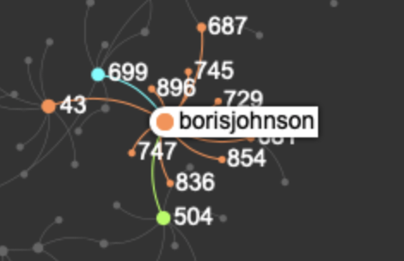

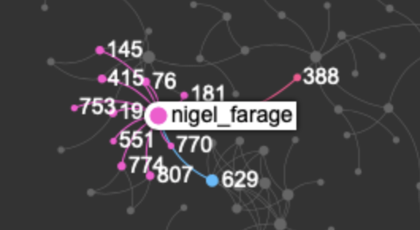

*Figure 7 Figure 8*

The figures above display the User Interaction Graph for tweets that contained only mentions and that are not retweets.

Using the data collected during the streaming of tweets, I manipulated and filtered the data in the database to only include tweets that have not been retweeted and which mention another user. I put this into a CSV file to make the data managable. In order to create the graphs above, I used a software provided by Netlytic to generate a user inter action graph.

As seen above, ‘borisjohnson’ can be displayed as a super user. A superuser, is a small minority that is responsible for a high proportion of the activity log posted. As my topic was ‘Brexit’, it can be expected that Boris Johnson was a superuser. He had 12 interactions alongside Nigel Farage who also had 12.

**RETWEETS ONLY**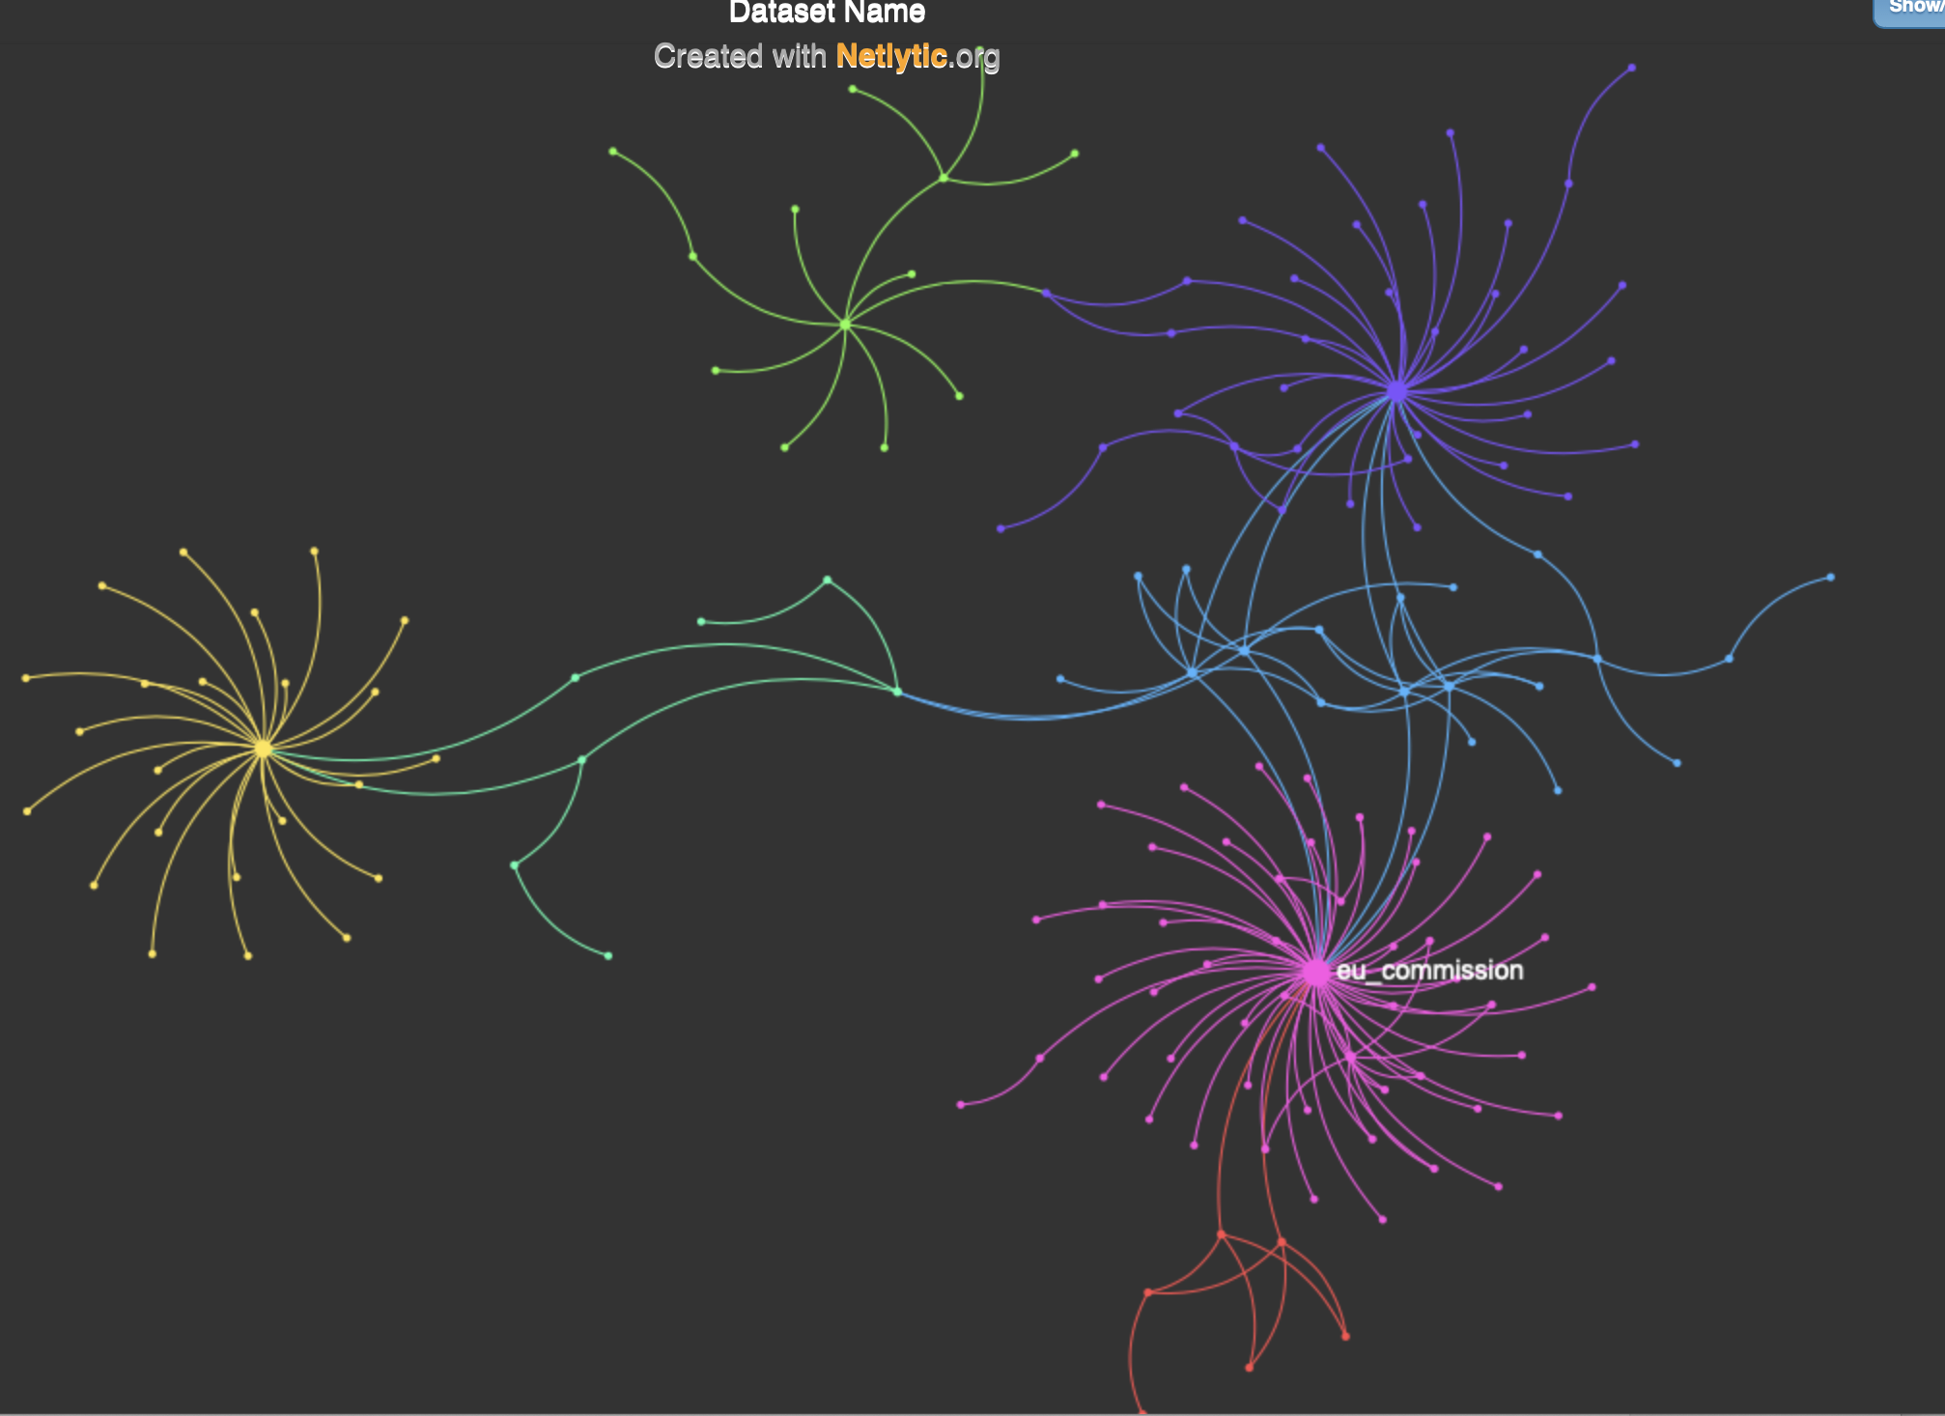

*Figure 9*

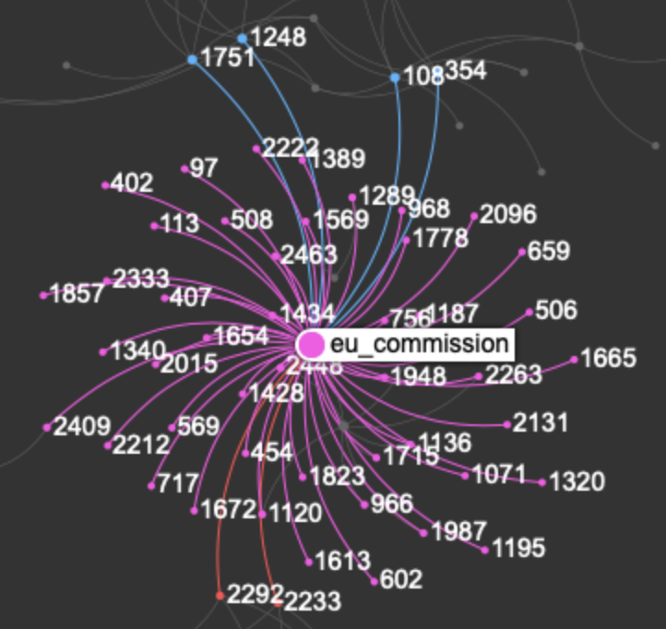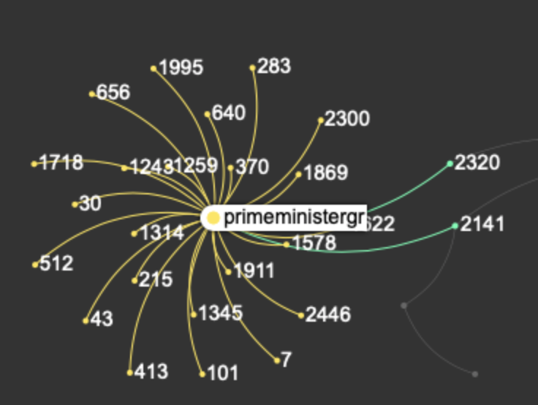

*Figure 10 Figure 11*

In order to generate a user interaction graph for the tweets that were only retweets, I first began my manipulating the original data in the CSV file, which contained the tweets I streamed at the beginning of this assignment. From this, I filtered the “text” of the tweet to only include “RT” which meant only including tweets that have been retweeted.

There is an obvious pattern between all the retweets as displayed in the graph above. This is because of all of the “RT” where linked to my key words of “brexit, boris and #brexit.” In comparison to the previous graph of “no retweet and mentioned users” only, the number of interactions in the retweet only graph was significantly higher, which is expected due to the type of social media that Twitter is.

As displayed in the graph, it can be seen that the “eu_commission” where in a high percentage of the RT. It had a total of 53 interactions. Similarly, “priminstergr” also was widely used within RT, and had a total of 25 interactions. This also is not unusual to occur due to the key words chosen.

**Hashtag Only** 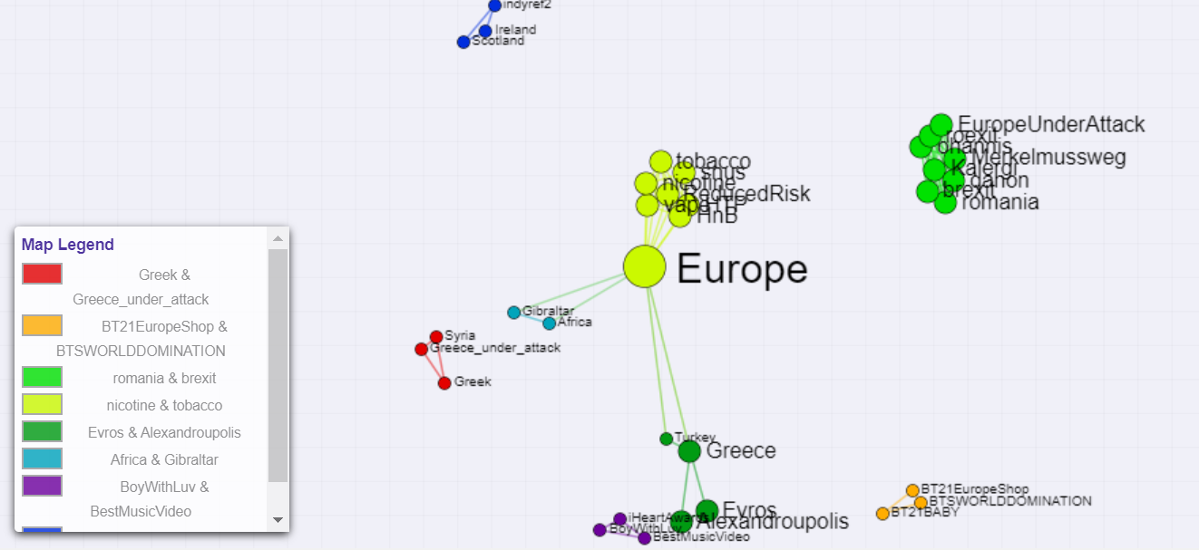

*Figure 12*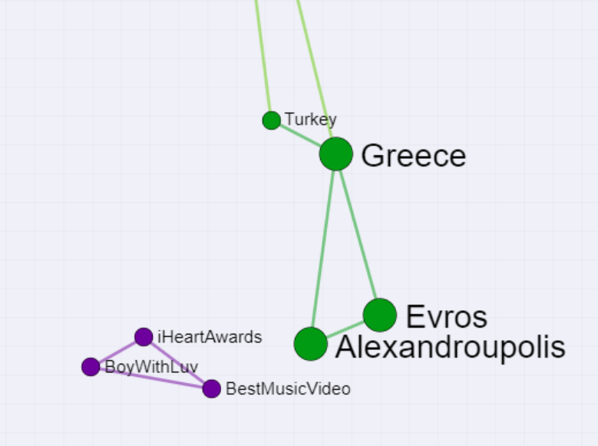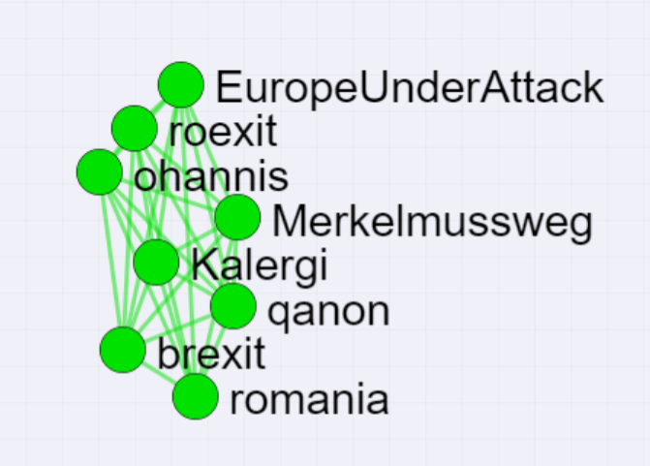

*Figure 13 Figure 14*

Repeating the same process as I did for above. I manipulated the original data in the CSV file collected to only contain what the author of the tweets hash-tagged. If there was no hashtag, then I omitted this from my data.

I used the software provided by Cortext to generate a user interaction graph for the hashtag only data.

To conclude, it can be seen in the graph that the most common hashtag used was “Europe”. This would be expected due to the fact Europe is the core of the Brexit Debate. Furthermore, Greece was also a main hashtag during the time which I streamed the tweets due to the debate that was occurring. However, less likely hashtags did also appear such as “Best Music Video” and “iHeartAwards”. The link between these hashtags to Brexit may be the fact that the Award Ceremony may have been happening in a country which is apart of the European Union.